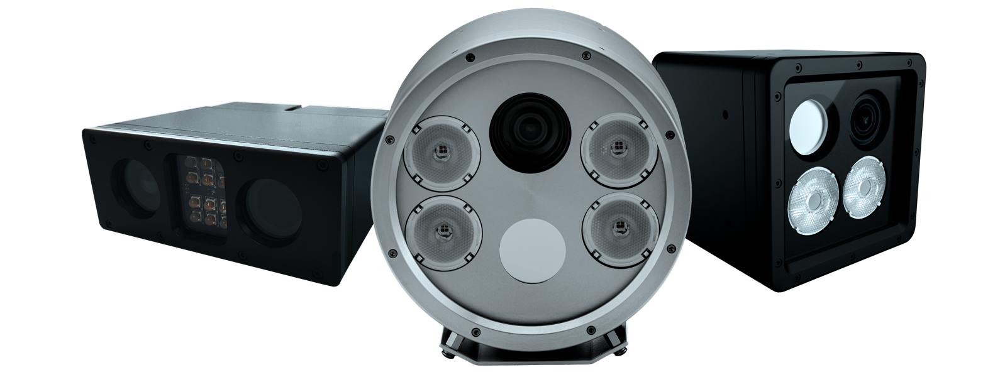
Product Safety

Rapier 50 User Manual Set up

CAMERA SETUP USER MANUAL
MAV IQ

If you have any questions about the safe operation of this system, consult your supplier or MAV before proceeding any further.
To ensure safe installation and use this product should be used only in accordance with the instructions and should not be modified. Modification invalidates product approvals and warranty.
It is the responsibility of the installer to ensure safe installation of this product in accordance with the applicable national regulations.
If you have any doubts at all as to the installation or use of this product, consult a competent person.

Contents
Product Safety 2
Contents 3
About this Guide 4
Readership 4
Related Publications 4
Trademarks and Acknowledgements 4
Conventions used in this Guide 4
Change History 4
Overview 5
Product Overview 5
Connections 5
Preliminaries 6
Getting Started 7
Apply Power 7
Connect Serial Port 7
Launch the Rapier50SD-2.5 Application 7
Select the COM Port 8
Camera Verification 8
Using Rapier Camera set Up 9
Camera Reset to Optimised Settings 10
Setting Up 11
Overview of Menu and Buttons 11
The Button Controls 11
ANPR Camera Buttons 11
Jog Zoom 11
FineFocus 12
Brightness 12
Target Position and GO Button 13
Jog Zoom 14
FineFocus 14
Camera Settings Buttons 15
STORE and RECALL 15
Presets 15
Menu Controls 16
Region Selection 16
Plate Size Selection 16
ANPR Setup Menu Selections 17
Overview Setup Menu Selections 17
Shutter Speed Menu Selections 19
Advanced Menu 19
Rapier Mono Alignment 19

About this Guide

This guide provides an overview to the software configuration of Rapier 50 ANPR cameras.
For your own safety you should read the Product Safety section before you use the system.
This guide describes the latest version; your particular unit may not exactly match it if it is operating with older software or hardware. Contact your supplier, or MAV, with the unit’s serial number for more details or to arrange an upgrade if required.

READERSHIP
This guide is for users, system integrators and installers. System integrators or installers are responsible for setting up the equipment for their users. System integrators and installers need to possess an understanding of video systems.
For ease of reference, the person using the application is called the "user" throughout this document.

RELATED PUBLICATIONS
Rapier 50 Technical Manual – required only for details of low level protocol information and physical connection details.

TRADEMARKS AND ACKNOWLEDGEMENTS
MAV is a registered trademark of MAV Systems Ltd.
Adobe, Acrobat and Reader are registered trademarks of Adobe Systems Incorporated in the United States and other countries.
Microsoft, Windows and Windows Vista are registered trademarks of Microsoft Corporation in the United States and other countries.

CONVENTIONS USED IN THIS GUIDE
 | This symbol indicates a warning. Follow the advice to avoid loss of data or equipment failure.
 | This symbol indicates danger. Follow the advice to avoid personal injury or serious damage.
 | This symbol indicates important information or a hint / tip.

Change History
1 December | 2.1 | Added support for Rapier 50 Mono
20 December | 2.2 | Update to control commands
21 July | 2.5 | Multi-Camera support

Overview

PRODUCT OVERVIEW
The Rapier 50 Camera Set Up application is designed for ease of use in configuring a Rapier 50 ANPR camera. From version 3.0 onwards, the application is compatible with both Rapier 50 Dual and Rapier 50 Mono products.

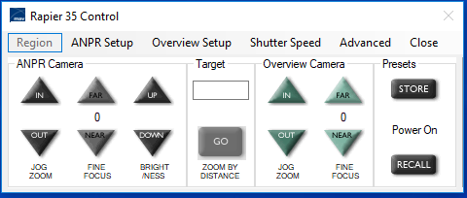

Whilst, the user should have a working knowledge of ANPR and CCTV systems, the application undertakes the low level commands to the camera and avoids the installer being required to use low level protocol commands.
The application is suitable for use with both fixed and mobile systems.

CONNECTIONS
For best use of the application, the user should have the facility to view the video from both cameras (ANPR and Overview) either simultaneously or by switching. This facility is normally provided by either the ANPR application itself or by use of a video monitor connected directly to the video cabling.
Before starting, connections from the Rapier 50 should be verified. At the controlling computer, there should be the following cables available:
- 9 way d-type serial connector (with RX/TX capability)
- ANPR Video (to be terminated into a single 75 ohm load)
- Overview Video (to be terminated into a single 75 ohm load) – only available on Rapier 50 Dual
- Power (nominally 15V DC isolated with 5A capability)

Without full duplex capability (i.e. both RX and TX serial data), this application will not be able to interrogate the camera and will not proceed past the startup screen.
The DC supply should be double insulated to provide isolation from the mains earth to improve noise immunity in the installation.

Preliminaries
The Rapier Camera Set Up application is written in Microsoft's .NET framework. The computer that will be running the application should have this .NET framework installed.

It is highly recommended that you install version 3.5.

If the .NET framework is not present, the application will quit after launch with a Windows Exception error that cannot be trapped.

The .NET Framework is available free of charge from Microsoft and can be downloaded as a full version from:
If the .NET framework is not present, the application will quit after launch with a Windows Exception error that cannot be
http://download.microsoft.com/download/6/0/f/60fc5854-3cb8-4892-b6db-bd4f42510f28/dotnetfx35.exe

The download for .NET 3.5 is around 200MB and should be downloaded from a static connection prior to arrival on site. Be aware not to use the smaller version which then requires an internet connection to complete installation.

Getting Started

APPLY POWER
Before running the application, the Rapier 50 should have power applied.

The Rapier 50 is supplied as factory default with the IR illuminators switched off. therefore, at time that power is applied it is normal for there to be no IR illumination and therefore no picture in the ANPR
video feed.

CONNECT SERIAL PORT
You must have a free serial COM port on your computer, this will be physically presented as a RS232 9-way D-type connection directly on the computer or via a USB serial device.
For multiple cameras you must have a free com port for each camera with a maximum of 4 cameras.
The application will automatically configure the COM port you are using and so no control of the COM port is required other than to run the application. It is essential to know the port allocation of this physical port connection as you will be asked for the COM port number as a first step as a selection from all COM ports enabled on your computer.
You must ensure that the selected port has no other applications or processes running that use the selected port, as COM ports can only support one application at any one time.

LAUNCH THE RAPIER 50 USER GUI 2.5 APPLICATION
The application is launched by double-clicking the executable Rapier 50 User GUI 2.5.exe.  If you have been sent the executable by email, you may be warned that the publisher cannot be verified. You should proceed only if you are sure that the application has been provided by a trustworthy source and not modified.  Windows 7 system may require the application to run in administration mode. To change the default setting click properties and compatibility tab. | 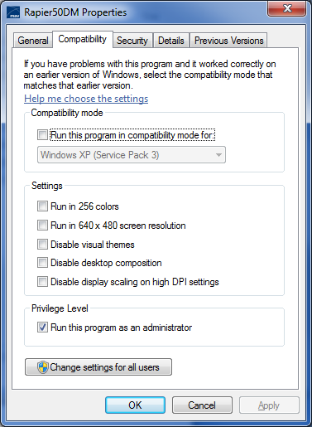

SELECT THE COM PORT  The first screen will appear and ask for you to select the COM port from a dropdown list of available ports.  You must ensure that the selected port has no other applications open on that port as COM ports can only support one application at any one time.  Select each COM port from the dropdown list and click OK to proceed. IMPORTANT the application must have a camera1 connected. | 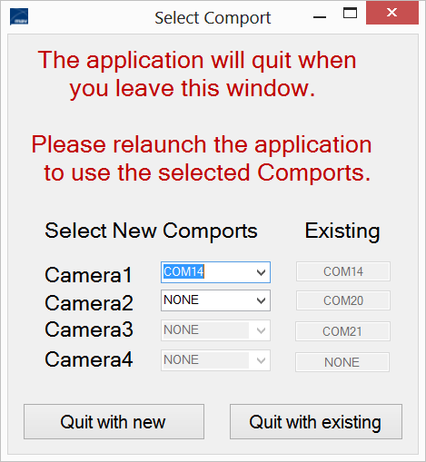
CAMERA VERIFICATION  The application requires the camera to be connected and powered at this stage so that it can interrogate the settings and establish initial parameters. | 
If you see the following screen, then you should check all power cabling and COM port allocation. RETRY until the communication is established. | 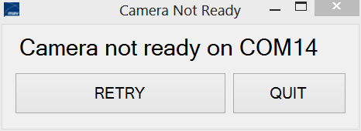

USING RAPIER CAMERA SET UP
Once started, you should see the following GUI for Rapier 50 Dual:

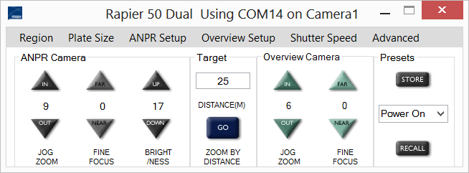

Or the following GUI for Rapier 50 Mono:

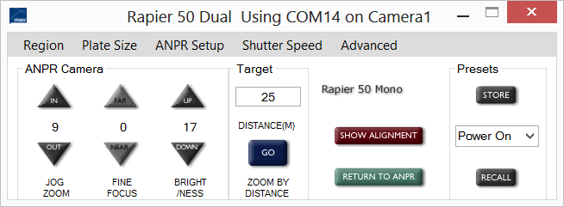

The application is an 'always-on-top' application that will remain in view. This enables the application to sit over other display applications. The window can be dragged and dropped as normal for Windows.

STARTING AT OPTIMISED SETTINGS – OVERRIDING FACTORY SETTINGS
The Rapier camera's own factory settings are basic parameters with the illuminator off and the cameras at full wide zoom.  By selecting the Advanced menu and selecting the RESET, the camera will be initialised to the latest optimised settings and these settings will be stored to Memory Preset 0 (the power up preset) as a new default (not factory), power-on setting. | 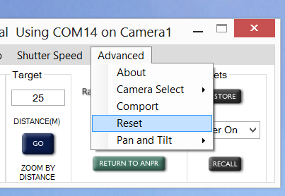

Performing RESET is a crucial part of establishing the latest optimised performance of the cameras
and should always be undertaken unless it is known that it has been performed recently at this version
of software.

Use of the RESET button on new installations is highly recommended but will overwrite the previous
Preset 0 settings. In general, this does not matter as the new settings will improve previous functionality.

If you are happy to proceed, press YES. | 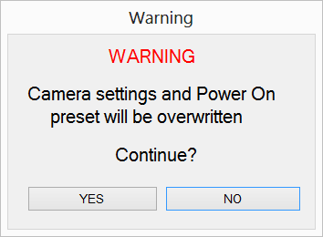

Setting Up

OVERVIEW OF MENU AND BUTTONS

THE BUTTON CONTROLS – ANPR CAMERA BUTTONS
Three buttons can be used for adjusting the zoom, fine focus and brightness of the ANPR image.
The Target GO option provides automation of the ANPR camera setup and should be read before choosing the desired method of setup through manual or calculated methods.

THE JOG ZOOM  The jogZoom feature moves the camera IN (towards the TELE end) or OUT (towards the WIDE end) of the zoom capabilities of the camera.  Each press of the Zoom also sets the focal distance of the camera to match that zoom value. i.e. the camera should be in focus at every step of zoom value. | 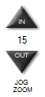

The fact that the focus is set for each zoom value is especially important for the ANPR camera as it often requires setting up when there are few images with retro-reflective plates in the field of view. It is also very useful where there is something within the field of view that is not a desired focus point (e.g. a window) that would otherwise cause false focus of any auto focus algorithm.

The JogZoom buttons should be used to establish the image of the license plate to be at the correct distance and proportion of the image for the ANPR engine that is installed.
The JogZoom feature has limits 1-30 in the optical zoom range.
The JogZoom value of 15 equates to a EU license plate (520mm) occupying 1⁄4 of the image at a distance of 30 metres; or a US plate (12") occupying 1⁄4 of the image at a distance of 90 feet.

FINEFOCUS  Whilst the JogZoom feature will set a good focus, the use of Fine Focus buttons can optimise the focus under manual control.  Pressing the NEAR button will pull the focus towards the camera. Pressing the FAR button will push the focus towards inifinity.  The relative movement will be shown in the centre of the buttons. Note that the fine focus will be reset every time the zoom is changed. | 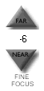

The amount of fine focus required at different zoom settings is non-linear. For extreme wide and tele settings, the level of fine focus can be up to 40-50 + or -. For central zoom positions, the movement will generally be +/- 10 at most.
SEE ALSO: ANPR Setup Menu Options – Focus Now. This facility allows a single autofocus but will require that an object is in view at the time it is initiated. Also note that it will not update the offset value and so subsequent use of Fine Focus will move the focus back to the relative level before the Focus Now command.
BRIGHTNESS  The Brightness control alters the Iris and the Gain of the camera in combination. The lowest brightness has the most 'closed' iris position and lowest gain.  As Brightness is increased by pressing the UP button, the level of Gain will be increased until a threshold is reached where the Iris is opened and the Gain slightly decreased.  The effect of this is that the brightness of the image is increased whilst maintaining a balance of closed Iris (for good depth of field of image) and lowest Gain (to reduce any artefacts introduced by electronic gain algorithms). | 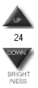
The level of Brightness required will also be dependant on the shutter speed of the camera (SEE ALSO: Shutter Speed Menu Options).
When setting an ANPR camera it should be noted that cars will not normally face the camera directly but will travel past at an offset angle. When setting up the camera it is therefore important to use a representative plate angle to set the Brightness and not have any sample plate at an un-obtainable angle (otherwise the real targets will be lower intensity). It is also worthy of note that the higher the angle of a plate, the less light the plate will reflect back to the camera. It is therefore very important to try to ensure camera locations that have the lowest angle of incidence to the passing traffic and thereby maximise the retro-reflective effects.

TARGET POSITION AND GO BUTTON  The Target GO option provides automation of the ANPR and Overview camera setup for zoom and focus based on the target distance of a vehicle's license plate.  For the distance entered, the application will calculate target angles, focal plane and set the zoom and focus of both the ANPR and Overview camera automatically.  Once set, further adjustment can be made by use of the JogZoom and FineFocus commands previously covered. | 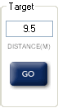

Before using the GO option, you should select the Region in which you are operating see menu buttons later in the section.

With the Region and Plate Size established, the user can enter any distance into the Target textbox and press the GO button (or the keyboard ENTER/CR).
For the Overview image, the zoom is set such that the field of view approximates to the width of a lane of traffic at the desired distance – this will normally capture a full car image to allow later contextual analysis, such as colour of vehicle and, where possible, pictures of the occupant

OVERVIEW CAMERA BUTTONS
These buttons are only available to users of the Rapier 50 Dual and they will be disabled when the application is started with a Rapier 50 Mono. For the alternative buttons available to Mono users, see later section.
Two buttons can be used for adjusting the zoom and fine focus of the Overview image.

JOGZOOM  The JogZoom feature moves the camera IN (towards the TELE end) or OUT (towards the WIDE end) of the zoom capabilities of the camera.  Each press of the Zoom also sets the focal distance of the camera to match that zoom value. i.e. the camera should be in focus at every step of zoom value.  The JogZoom buttons should be used to establish the desired overview image of the vehicle who's license plate is within the ANPR image. It is usual for the Overview image to be set to a wider field of view so that more of the vehicle can be seen and from this make, model and colour be determined.  The JogZoom feature has limits 1-30 in the optical zoom range. | 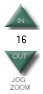
FINEFOCUS  This option is only available if the camera is in Manual Focus mode. SEEALSO: Overview Setup Menu Options. A range of focus options are available in this menu including Auto Focus, Manual Focus, Focus on Zoom and a Focus Now facility that triggers a single autofocus action on any object is in view at the time it is initiated.  After the JogZoom feature has set a good focus, the use of Fine Focus buttons can optimise this focus under manual control. | 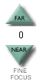

Pressing the NEAR button will pull the focus towards the camera. Pressing the FAR button will push the focus towards infinity. The relative movement will be shown in the centre of the buttons.
Note that the fine focus will be reset every time the zoom is changed.
The amount of fine focus required at different zoom settings is non-linear. For extreme wide and tele settings, the level of fine focus can be up to +/- 40-50 . For central zoom positions, the movement will generally be +/- 10.

CAMERA SETTINGS BUTTONS
STORE AND RECALL  The two buttons can be used to store and recall a preset. The preset used is the camera's Power-on-Preset (Memory 0).  The STORE will perform an immediate save for both the ANPR and the Overview cameras plus the illuminator settings.  If, at any time during the use of the Rapier CameraSetUp application the user wishes to return to the last stored values, the RECALL button will overwrite all changed values and restore the cameras and illuminator to the same conditions as would be initiated when the camera's power is cycled. The RECALL function will also reset the values shown against the JogZoom, FineFocus and Brightness buttons for ANPR and Overview cameras. | 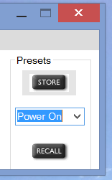
PRESETS  The camera supports 8 Presets including the Power On, you can save or recall different pre-sets from the drop down list. | 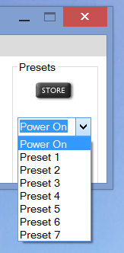

MENU CONTROLS – REGION SELECTION
Region selection is used by the Target GO option documented above.

For plates in the EU, a typical front and rear plate is 520mm wide. Selecting EU will use this plate width as the basis of calculations. Further, it will set the unit of measurement to metres (m).

For plates in the US, a typical front and rear plate is 12  inches wide. Selecting US will use this plate width as the basis of calculations. Further, it will set the unit of measurement to feet (ft). | 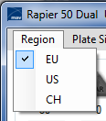
PLATE SIZE SELECTION  Plate Size selection is used by the Target GO option documented above. This option is used to select the Plate Size that you wish the camera to zoom to. This size will be dependent on the capabilities of the ANPR engine in use and is typically either ¼ or 1/5 of the total image width.  For example: Where 4 is selected for an EU plate, the GO button will calculate and set the ANPR camera's zoom to be approx 2m left to right (520mm * 4) at the required distance and will also set the focal plane to match that distance. | 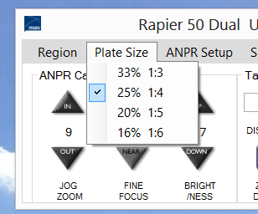
For instances where there may be no license plates in the field of view at the time of setting up the camera, this functionality is essential. It is also very useful where other objects may be within the field of view and would detract from the focus of the camera in any automatic mode of operation.

ANPR SETUP MENU SELECTIONS
The ANPR Setup Menu allows the user to switch the IR illuminators on or off. The current status of the IR illuminators will
be shown.

IR power setting should be set as low as possible for maximum efficiency. It is better always better
increase the brightness.

Additionally, the user may select the Focus Now option. This facility triggers a single autofocus action but will require that an object is in view at the time it is initiated that is visible to the ANPR camera (i.e. a retro reflective item). | 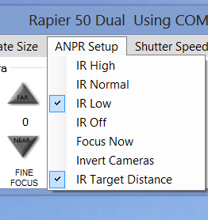

Performing Focus Now. It is better to turn the brightness of the image up. The more detail in the image the better focus will be. Do not use this option on moving vehicles.

Note that it will not update the offset value and so subsequent use of Fine Focus will move the focus back to the relative level
before the Focus Now command.

OVERVIEW SETUP MENU SELECTIONS
This menu is only available to users of the Rapier 50 Dual and they will be disabled (greyed out) when the application is started with a Rapier 50 Mono.
The Overview Setup Menu allows the user to select the mode of operation for the focus of the Overview camera.

AUTO FOCUS MODE  will have the camera constantly trying to establish a focus on an object within the field of view. This mode of operation is not recommended as it can lead to focus being established on objects that are not the desired subject. When in this mode, JogZoom will only send zoom commands and will not attempt to focus the camera to the optimal level. | 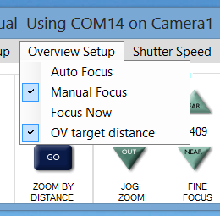

Manual Focus mode – is the preferred option With Focus Now each time the Jog Zoom command is used. Manual Focus will also enable the FineFocus buttons.

Focus Now. This facility triggers a single autofocus action and will work in all 3 of the above modes of operation.

FOCUS NOW
This facility triggers a single autofocus action and will work in all 3 of the above modes of operation.

OV TARGET DISTANCE
Use this option to move the overview camera to the same field of view as the ANPR camera when target distance commands
are used.

SHUTTER SPEED MENU SETTINGS  Shutter Speed Menu allows a choice of ANPR or Overview shutter speed combinations for the ANPR Under most traffic conditions, 1/1600th will provide crisp images for the ANPR engine. Only for very high traffic speeds should higher shutter speeds be necessary and it should be noted that halving the shutter speed will obviously half the amount of illumination on the license plate and also make them duller. With higher speeds,  the Brightness will have to be increased. | 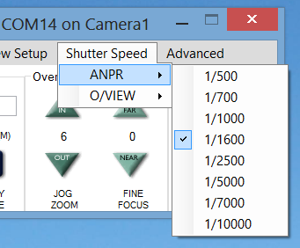
Overview Menu allows a choice of shutter Speed 1/500 is typical setting for general conditions. In Normal daylight you will see little difference as the camera is in shutter priority mode so tries to maintain constant image brightness. | 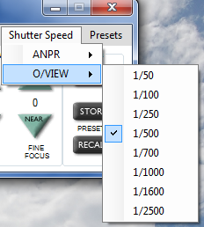
ADVANCED MENU  This menu is for users that have the Rapier 50 installed and require some additional information. | 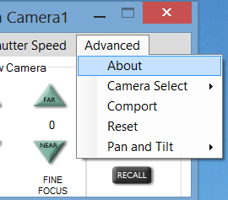
About, provides s/w and firmware revisions and voltage information. Note the minimum voltage is 10 Volts | 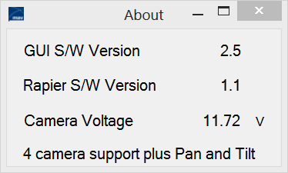
Camera Select, up to 4 cameras are supported, as you select a camera it will retrieve the camera settings and populate the GUI interface. | 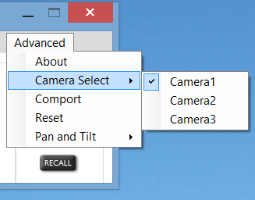
Comport, Change comport numbers, note you must always define camera 1 for the software to initialise. | 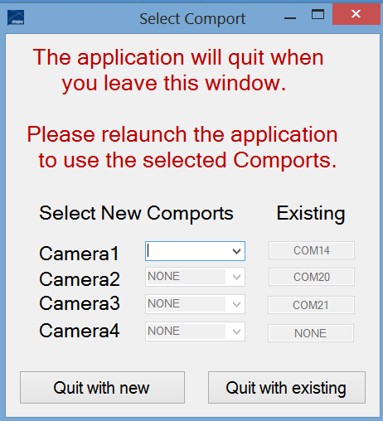
Reset, Restore software to defaults. Use if you are unsure about camera status.

Pan and Tilt, this is an optional set of controls and may not be available in all versions. | 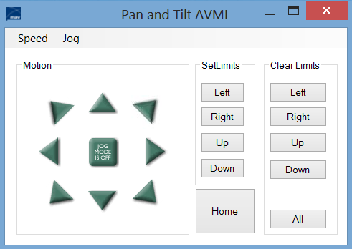

RAPIER MONO ALIGNMENT
When there is no overview camera, it is often hard to determine the exact field of view and zoom/focus that the IR camera has. This is especially true when setting up the camera in situations where the number of passing vehicles is low. To help this situation, the Overview Camera buttons present on the Dual are replaced by Alignment buttons, as shown below.

Pressing the SHOW ALIGNMENT button will set the IR camera into auto exposure mode where it will open the iris to its maximum and use gain to expose the brightest picture possible. An example of an exposed alignment image is shown on next page.

When alignment is achieved through use of Pan and Tilt or manually adjusting the brackets, the camera must be reset to normal ANPR mode by pressing the RETURN TO ANPR button. | 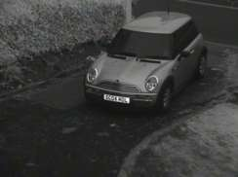
When this is done, the image should return to a low background video – when retro- reflective plates are in view, they should be visible and normal control of the ANPR buttons can fine tune for zoom, focus and  brightness of the image. | 